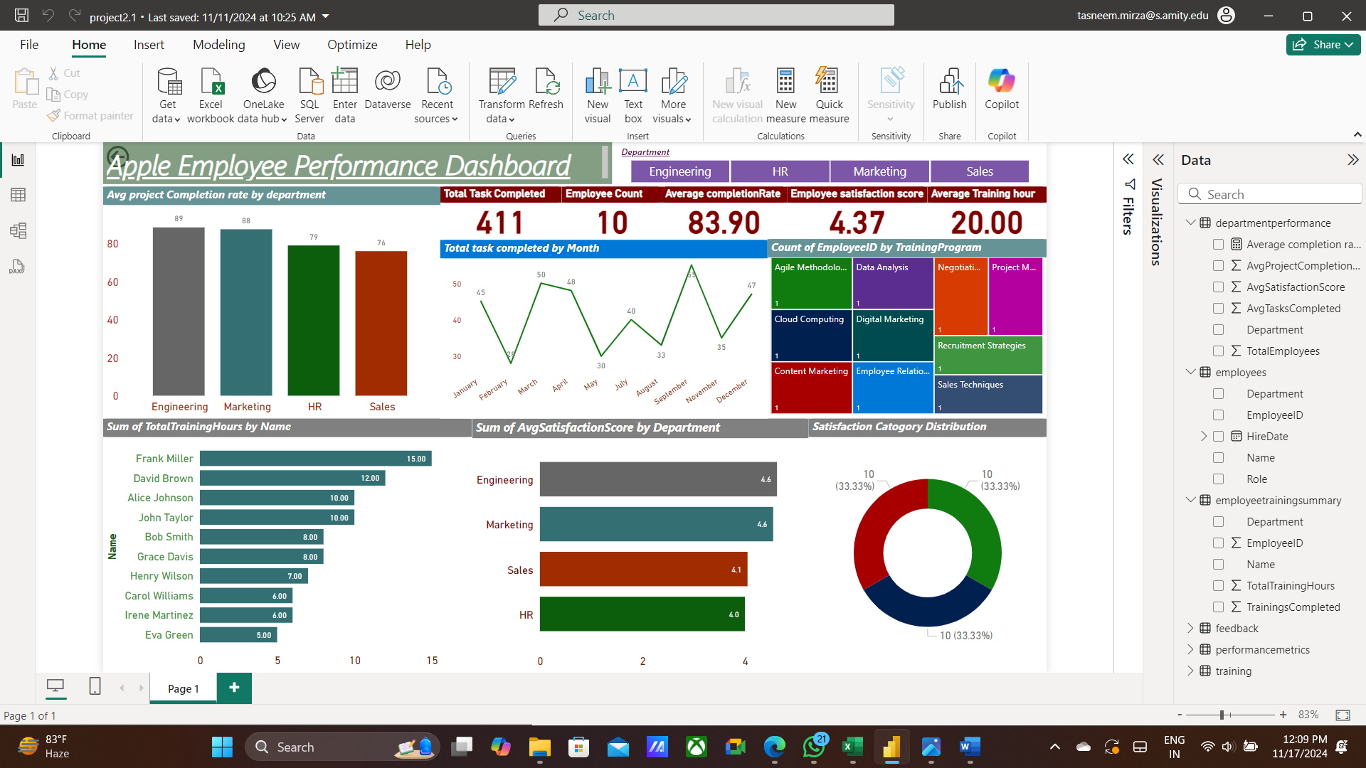

This is an **Apple Employee Performance Dashboard**, providing insights into employee performance, satisfaction, and training activities. Here's what each visualization shows:

1. **KPI Cards (Top Row)**:
   * **Total Tasks Completed (411)**: Total number of tasks completed across all employees.
   * **Employee Count (10)**: Total number of employees included in the analysis.
   * **Average Completion Rate (83.90)**: The overall average percentage of project completion.
   * **Employee Satisfaction Score (4.37)**: The average satisfaction score among employees.
   * **Average Training Hours (20.00)**: The average training hours completed per employee.
2. **Average Project Completion Rate by Department (Bar Chart)**: Shows the average project completion rate for each department (e.g., Engineering, Marketing, HR, Sales), helping identify high- or low-performing departments.
3. **Total Tasks Completed by Month (Line Chart)**: Highlights the number of tasks completed monthly, showing trends over the year.
4. **Count of EmployeeID by Training Program (Treemap)**: Breaks down the number of employees participating in different training programs like Agile Methodologies, Data Analysis, etc.
5. **Sum of Total Training Hours by Name (Bar Chart)**: Displays training hours for each employee, showing who completed the most training.
6. **Sum of Average Satisfaction Score by Department (Bar Chart)**: Compares the average employee satisfaction scores across departments.
7. **Satisfaction Category Distribution (Donut Chart)**: Shows the distribution of satisfaction categories (e.g., high, medium, or low satisfaction).

**Key Takeaways:**

This dashboard helps stakeholders monitor employee performance and engagement. It identifies top-performing departments, tracks task completion trends, evaluates training effectiveness, and measures employee satisfaction levels for data-driven HR decisions.